**MOVIE TICKET BOOKING APPLICATION**

**Application:**

* New user must register and then login.
* After logging in, the user is redirected to welcome page.
* The user must select location, language of movie and date.
* Choose a movie from the shown (available) choices.
* Select number of tickets which cannot be more than available tickets in the selected theatre.
* The user cannot select theatre which shows houseful status.
* User can change the selection of location, movie at any time.
* Make payment.
* View his profile (booking history).
* The user can logout at any point in time.

**Sequence Diagram:**

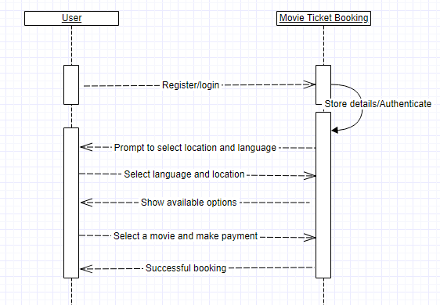

The application

* Cannot get the real time location of user. He must select the location from the available choices only.
* Has no forgot password functionality.
* Has no payment gateway (it just displays dummy payment page).